# **Department of Computer Science and Engineering Islamic University of Technology (IUT)** A subsidiary organ of OIC

# **Lab Report 01**

# CSE 4412: Computer Networks Lab

## 

## **Name: Khalid Hasan Ador Student ID: 210042102 Section: B Semester: 4th (Summer) Academic Year: 2023-2024**

**Date of Submission: 28/01/24**

### **Title:** Configure router using static routing to connect multiple networks in Cisco Packet Tracer

### **Objectives**:

1. Understand how to operate Cisco Packet Tracer
2. Learn to create and connect multiple networks using static routing
3. Understand wiring of different network components like router, switch, PC etc.
4. Configure router and switch interfaces
5. Verify connectivity of the network
6. Understand the basics of IP Subnetting
7. Learn to subnet a network following given specifications

### **Diagram of the experiment:**

(Provide screenshot of the final network topology. Make sure to label the network components.)

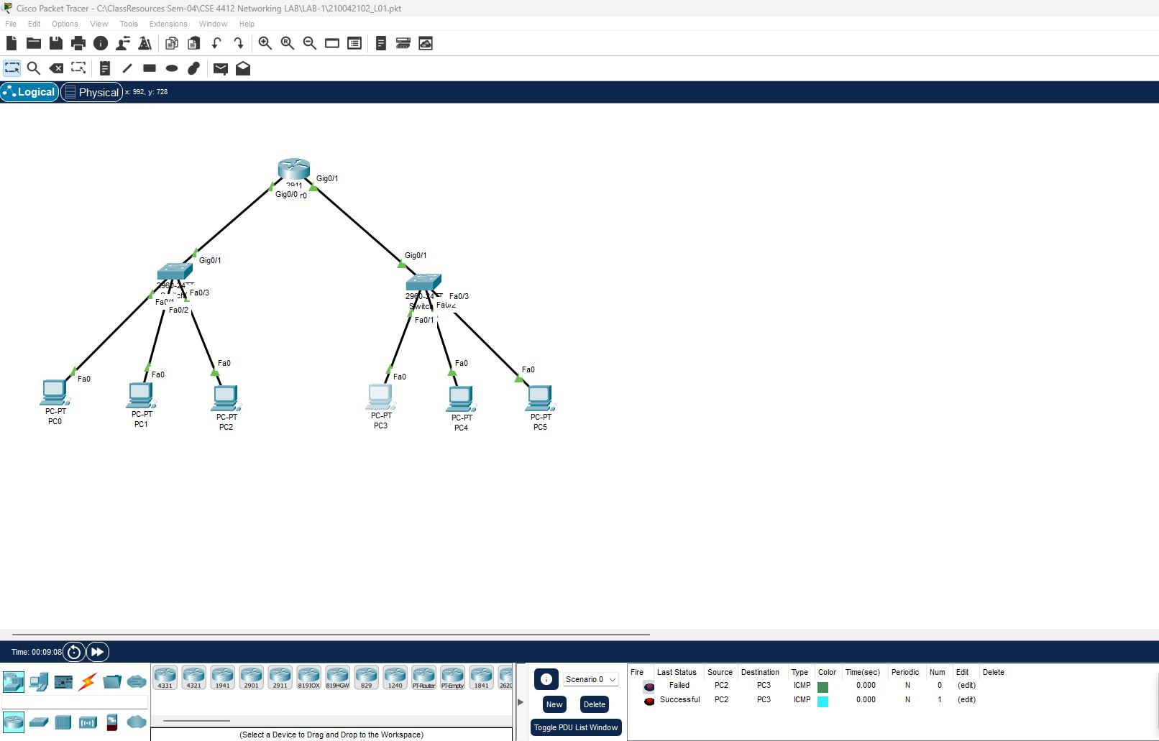

### **Working Procedure:**

**(**Explain in brief how you completed the tasks. Provide necessary screenshots of used commands for each task.)

1. First of all I created the network topology.
2. Changed hostname of the router

Router(config)# hostname 102

1. Configured the 2 interfaces

Enter Interface setup mode: 102(config)\# interface gigabitEthernet 0/0

102(config-if)\# ip address 192.168.02.1 255.255.255.0

102(config-if)\# no shutdown

1. Configured the IP addresses and default gateways of each connected PC.

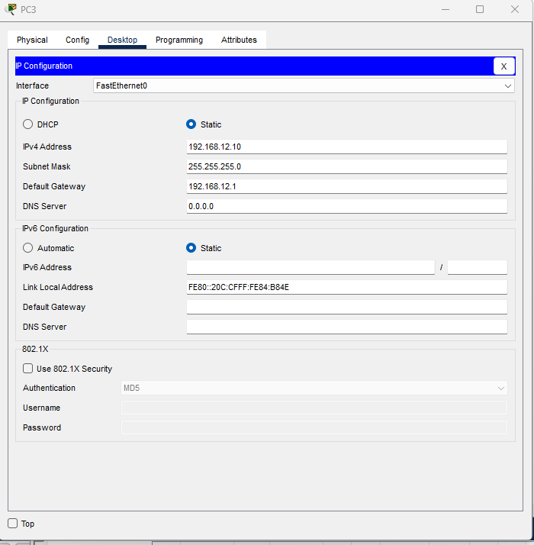

### **Questions (Answer to the point)**:

**Q1.** Write the command to check the status of all interfaces in a router.

Ans:

102# show interface

Or,

102# show ip interface brief

**Q2.** Why do we use switches and not hubs?

Ans: Hubs broadcast data to all connected devices but Switch can broadcast to a specific device.

**Q3.** How do you make all the configuration changes in a cisco device persistent? What would happen if you don’t do this?

Ans: 102# copy running-config startup-config.

All the configurations will be lost if the device losses power.

**Q4.** What are the interfaces of the router? Why are they necessary?

Ans: Interfaces connect a full network.

**Q5.** Why is default gateway necessary?

Ans: To specify the interface of a device.

### **Challenges (if any):**

1. Was trying to save the configuration in global configuration mode.

### 